**Techincal Training Practice Questions**

1. **Prime Number b/w 1 to N.**

**import** java.util.*;

**public** **class** prime_num {

**public** **static** **void** main(String[] args) {

// Program to Print prime number between 1 to N

**int** i,count;

System.***out***.print("Enter value of N : ");

Scanner sc=**new** Scanner(System.***in***);

**int** n=sc.nextInt();

System.***out***.println("Prime numbers between 1 to "+n+" are ");

**for**(**int** j=2;j<=n;j++)

{

count=0;

**for**(i=1;i<=j;i++)

{

**if**(j%i==0)

{

count++;

}

}

**if**(count==2)

System.***out***.print(j+" ");

}

}

}

**OUTPUT :--**

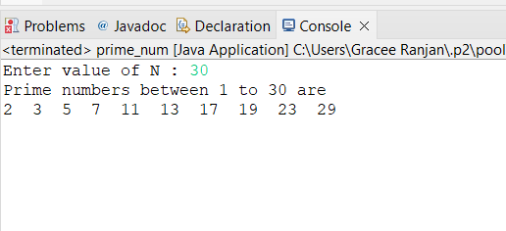

1. **1 to N Number Armstrong**

**import** java.util.*;

**public** **class** ArmStrongNumInRange {

**public** **static** **void** main(String[] args) {

**int** n, count = 0, a, b, c, sum = 0;

Scanner sc = **new** Scanner(System.***in***);

System.***out***.println("Enter the Value for N:");

**int** no = sc.nextInt();

System.***out***.print("Armstrong numbers from 1 to "+no+" are = ");

**for** (**int** i = 1; i <= no; i++)

{

n = i;

**while** (n > 0)

{

b = n % 10;

sum = sum + (b * b * b);

n = n / 10;

}

**if** (sum == i)

{

System.***out***.print(i + " ");

}

sum = 0;

}

}

}

**OUTPUT :---**

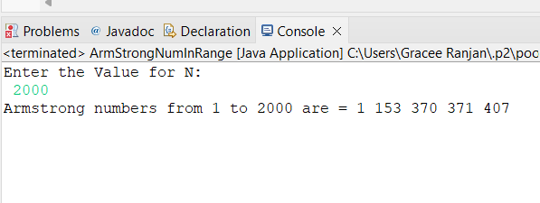

1. **Print 1 to N Tables**

**import** java.util.*;

**public** **class** num_table {

**public** **static** **void** main(String[] args) {

Scanner sc = **new** Scanner(System.***in***);

System.***out***.print("Enter number: ");

**int** num=sc.nextInt();

System.***out***.println("Table of "+num+" is as follows :- \n");

**for**(**int** i=1; i <= 10; i++)

{

System.***out***.println(num+" * "+i+" = "+num*i);

}

}

}

**OUTPUT :--**

1. **Patterns**

**1**

**22**

**333**

**4444**

**55555**

**import** java.util.*;

**public** **class** num_pattern {

**public** **static** **void** main(String[] args) {

**int** i,j,n;

System.***out***.print("Input number of n : ");

Scanner in = **new** Scanner(System.***in***);

n = in.nextInt();

**for**(i=1;i<=n;i++)

{

**for**(j=1;j<=i;j++)

System.***out***.print(i);

System.***out***.println("");

}

}

}

**OUTPUT :---**

1. **Patterns**

**A**

**AB**

**ABC**

**ABCD**

**ABCDE**

**import** java.util.*;

**public** **class** alphabet_pattern {

**public** **static** **void** main(String[] args) {

**int** i,j,n;

Scanner sc = **new** Scanner(System.***in***);

System.***out***.println("Enter the no of lines");

n=sc.nextInt();

**for**(i=1;i<=n;i++)

{

**for**(j=1;j<=(i*2-1);j++)

{

System.***out***.print((**char**)(j+64)+" ");

}

System.***out***.println("");

}

}

}

**OUTPUT :--**

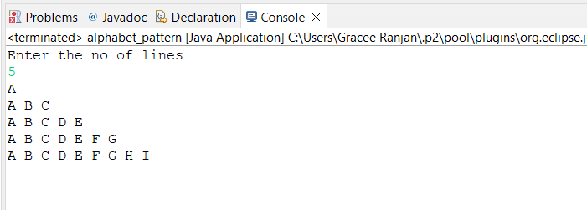

1. **Patterns**

**A**

**BB**

**CCC**

**DDDD**

**EEEEE**

**import** java.util.*;

**public** **class** Alphabet_pattern2 {

**public** **static** **void** main(String[] args) {

**int** n;

Scanner sc= **new** Scanner(System.***in***);

System.***out***.println("Enter the no of lines");

n=sc.nextInt();

**for**(**int** i = 0 ; i <= n ; i++)

{

**for**(**int** j = 0 ; j <= i ; j++)

{

System.***out***.print(" "+(**char**)(65 + i));

}

System.***out***.println("");

}

}

}

**OUTPUT :--**

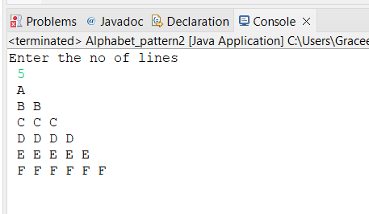

1. **Patterns**

**\***

**\*\***

**\*\*\***

**\*\*\*\***

**\*\*\*\*\***

**import** java.util.*;

**public** **class** star_pattern {

**public** **static** **void** main(String[] args) {

**int** row;

Scanner input = **new** Scanner(System.***in***);

System.***out***.println("Enter Number of Rows of Stars : ");

row=input.nextInt();

**for** (**int** i=0; i<row; i++)

{

//inner loop work for space

**for** (**int** j=2*(row-i); j>=0; j--)

{

//prints space between two stars

System.***out***.print(" ");

}

//inner loop for columns

**for** (**int** j=0; j<=i; j++ )

{

//prints star

System.***out***.print("* ");

}

//brings the cursor in a new line after printing each line

System.***out***.println();

}

}

}

**OUTPUT :---**

